Due: 4/15 6/15 9/15 1/15
- https://drsbustax.ct.gov/AUT/welcomebusiness.aspx
  - Enter your CT registration number
  - Enter user ID and password.
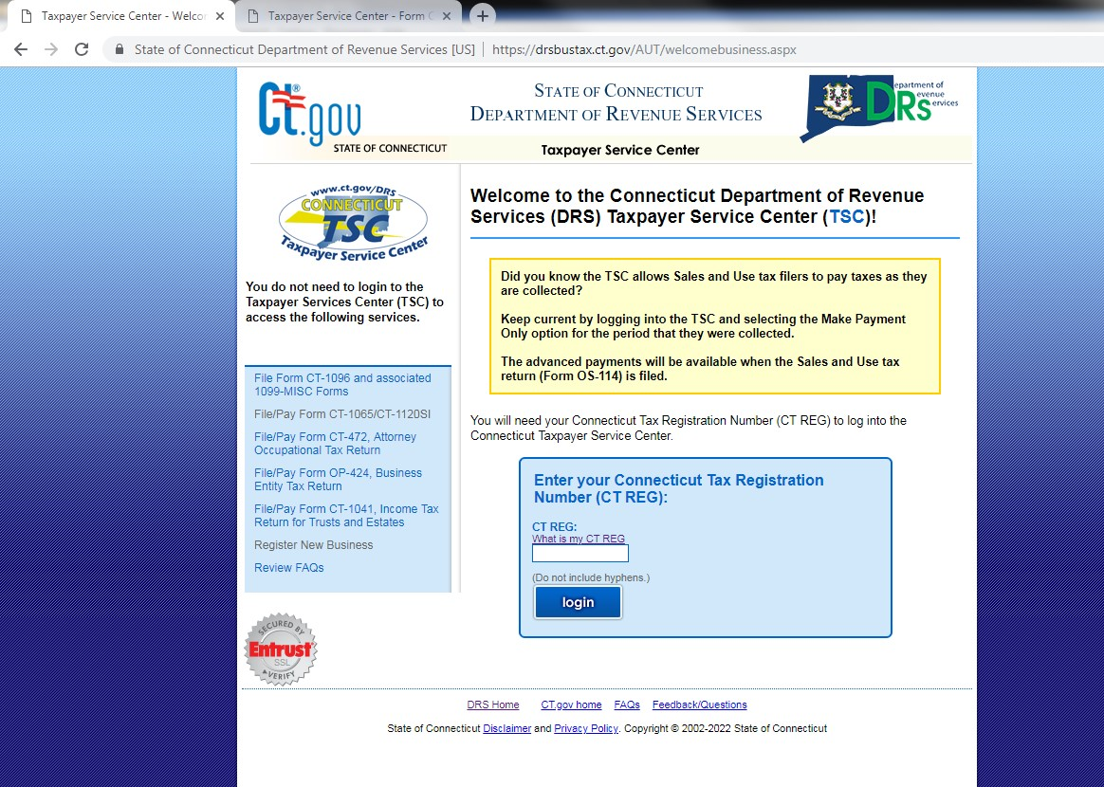

- After logging in, click the link “Form CT-1065/1120SI”

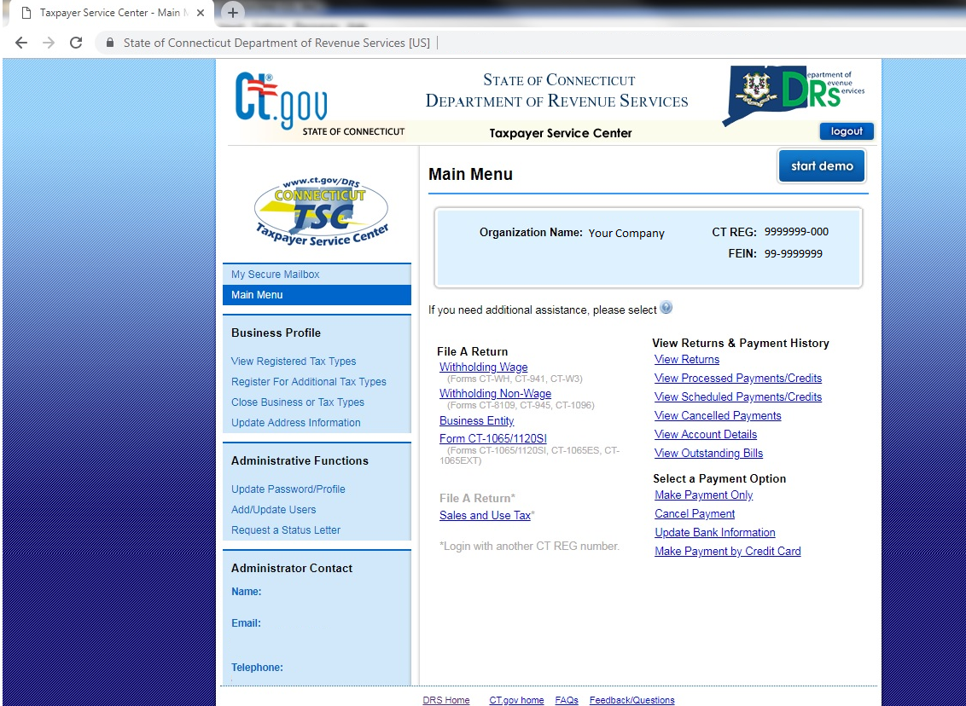
- For estimated payments click the link ending ‘ES’

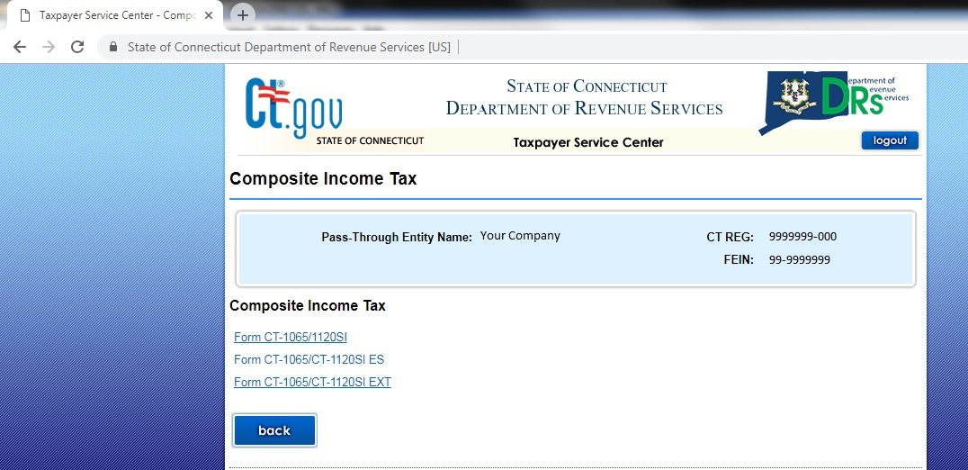

- Enter the dates for the period the payment should be applied.

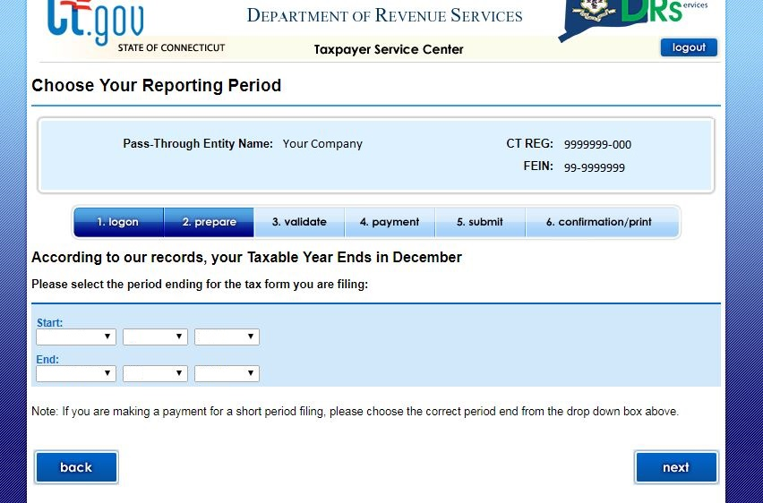

- Enter the amount of the payment.

