https://drsbustax.ct.gov/AUT/welcomebusiness.aspx
Click second option, File/Pay Form CT-1065/CT-1120SI
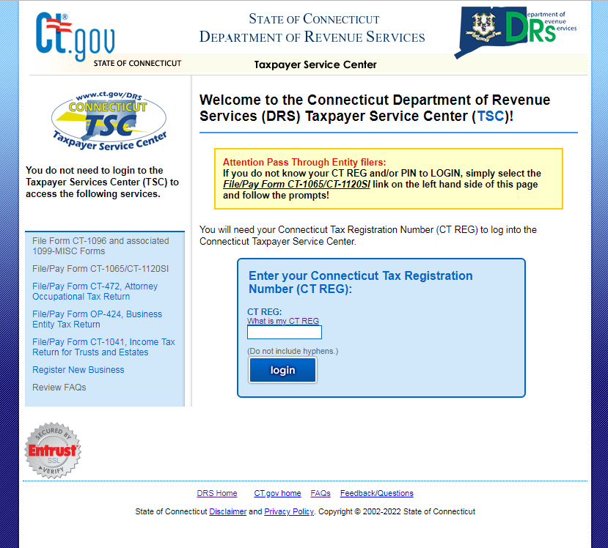

Use “Make an Estimated Payment” option

